

Department of Computer Technology

Vision of the Department
To be a well-known centre for pursuing computer education through innovative pedagogy, value-based education and industry collaboration.

Mission of the Department
To establish learning ambience for ushering in computer engineering professionals in core and multidisciplinary area by developing Problem-solving skills through emerging technologies.

Session 2025-2026
Program Educational Objectives of the program (PEO): (broad statements that describe the professional and career accomplishments)
PEO1 | Preparation | P: Preparation | Pep-CL abbreviation pronounce as  Pep-si-lL easy to recall
PEO2 | Core Competence | E: Environment  (Learning Environment) | Pep-CL abbreviation pronounce as  Pep-si-lL easy to recall
PEO3 | Breadth | P: Professionalism | Pep-CL abbreviation pronounce as  Pep-si-lL easy to recall
PEO4 | Professionalism | C: Core Competence | Pep-CL abbreviation pronounce as  Pep-si-lL easy to recall
PEO5 | Learning  Environment | L: Breadth (Learning in  diverse areas) | Pep-CL abbreviation pronounce as  Pep-si-lL easy to recall

Program Outcomes (PO): (statements that describe what a student should be able to do and know by the end of a program)
Keywords of POs:
Engineering knowledge, Problem analysis, Design/development of solutions, Conduct Investigations of Complex Problems, Engineering Tool Usage, The Engineer and The World, Ethics, Individual and Collaborative Team work, Communication, Project Management and Finance, Life-Long Learning
PSO Keywords: Cutting edge technologies, Research
“I am an engineer, and I know how to apply engineering knowledge to investigate, analyse and design solutions to complex problems using tools for entire world following all ethics in a collaborative way with proper management skills throughout my life.” to contribute to the development of cutting-edge technologies and Research.

Integrity: I will adhere to the Laboratory Code of Conduct and ethics in its entirety.

Name and Signature of Student and Date
Hrutik Gujarkar
(Signature and Date in Handwritten)

Department of Computer Technology

Vision of the Department
To be a well-known centre for pursuing computer education through innovative pedagogy, value-based education and industry collaboration.

Mission of the Department
To establish learning ambience for ushering in computer engineering professionals in core and multidisciplinary area by developing Problem-solving skills through emerging technologies.

Session | 2026-27 (EVEN) | Course Name | Optimization Techniques Lab
Semester | 7 | Course Code | 23ADS1708
Roll No | 39 | Name of Student | Hrutik Gujarkar

s
Practical Number | 10 (Mini Project)
Course Outcome | Understand unconstrained and constrained optimization techniques.
Aim | Optimization Techniques Mini Project To obtain an initial feasible solution and optimal solution for a Transportation Problem using Northwest Corner Method, Least Cost Method, Vogel’s Approximation Method (VAM), and Stepping Stone Method.
Theory | The Transportation Problem is a special type of Linear Programming Problem in which a single commodity is shipped from several source (supply points) to several destinations (demand points) at the minimum tota transportation cost.  Objective function:  Minimize Z = ΣΣ cᵢ xᵢ subject to:  - Σ xᵢ = supplyᵢ (for each source)  - Σᵢ xᵢ = demand (for each destination)  - xᵢ ≥ 0  where cᵢ is the cost per unit from source i to destination j, and xᵢ is the quantity shipped. The problem is balanced when total supply equals tota demand (here 90 = 90).  Solving has two stages:  - Initial Basic Feasible Solution (IBFS), obtained by one of these:  - Northwest Corner Method (NWCM): starts at the top-lef cell and allocates the maximum possible, moving right or down. It ignores costs, so it is simple but usually far from optimal.  - Least Cost Method (LCM): allocates first to the cell with the lowest unit cost, so it generally gives a better starting solution.  - Vogel’s Approximation Method (VAM): calculates row and column penalties (difference between the two smallest costs) allocates in the line with the highest penalty at its cheapes cell, and usually gives the best IBFS.  - Optimality test, for example the Stepping Stone Method or MODI (u-v) method. It computes the opportunity cost of each empty cel using closed paths, and improves the solution until no empty cell has a negative value.
Procedure and Execution | Steps:

- Define the cost matrix, supply and demand.

- Check that the problem is balanced.

- Apply the Northwest Corner Method to get an initial solution.

- Apply the Least Cost Method to get an initial solution.

- Apply Vogel's Approximation Method (VAM) to get an initial solution.
- Compute the total transportation cost for each method.

- Compare the costs and select the lowest.

- Verify optimality using the Stepping Stone / MODI method.

- Display the results.

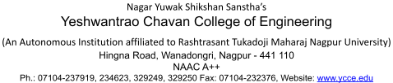
Code:
import numpy as np import pandas as pd
import matplotlib.pyplot as plt from scipy.optimize import linprog

# Data
cost = np.array([[2, 3, 1],
[5, 4, 8],
[5, 6, 8]])
supply = [30, 40, 20]
demand = [20, 30, 40]
print("Balanced:", sum(supply) == sum(demand))

def total_cost(alloc):
return int(np.sum(alloc * cost))

# -- 1. Northwest Corner Method
- def northwest_corner(cost, supply,
demand):
s, d = supply.copy(), demand.copy() alloc = np.zeros(cost.shape, dtype=int) i = j = 0
while i < len(s) and j < len(d): x = min(s[i], d[j]) alloc[i][j] = x
s[i] -= x
d[j] -= x
if s[i] == 0: i += 1
else:
j += 1
return alloc

# -- 2. Least Cost Method

- def least_cost(cost, supply,
demand):
s, d = supply.copy(), demand.copy()

alloc = np.zeros(cost.shape, dtype=int) c = cost.astype(float).copy() while np.isfinite(c).any():
i, j = np.unravel_index(np.argmin(c), c.shape) x = min(s[i], d[j])
alloc[i][j] = x
s[i] -= x
d[j] -= x
if s[i] == 0: c[i, :] = np.inf
if d[j] == 0: c[:, j] = np.inf return alloc

# -- 3. Vogel's Approximation Method
- def vam(cost, supply, demand):
s, d = supply.copy(), demand.copy() alloc = np.zeros(cost.shape, dtype=int) c = cost.astype(float).copy()

def penalty(v):
v = np.sort(v[np.isfinite(v)]) if len(v) > 1: return v[1] - v[0]
return v[0] if len(v) == 1 else -1

while np.isfinite(c).any():
rp = [penalty(c[i, :]) for i in range(c.shape[0])] cp = [penalty(c[:, j]) for j in range(c.shape[1])] if max(rp) >= max(cp):
i = int(np.argmax(rp)); j = int(np.argmin(c[i, :])) else:
j = int(np.argmax(cp)); i = int(np.argmin(c[:, j])) x = min(s[i], d[j])
alloc[i][j] = x
s[i] -= x
d[j] -= x
if s[i] == 0: c[i, :] = np.inf
if d[j] == 0: c[:, j] = np.inf return alloc

# ---------- Run all methods ----------

results = {
"Northwest Corner": northwest_corner(cost, supply, demand), "Least Cost": least_cost(cost, supply, demand),
"VAM": vam(cost, supply, demand),
}

for name, alloc in results.items(): print(f"\n{name} - Allocation Matrix:") print(alloc)
print("Total Cost =", total_cost(alloc))

# Optimal solution (verification)
- m, n = cost.shape
A_eq, b_eq = [], supply + demand for i in range(m):
row = np.zeros(m * n); row[i*n:(i+1)*n] = 1; A_eq.append(row) for j in range(n):
col = np.zeros(m * n); col[j::n] = 1; A_eq.append(col)
res = linprog(cost.flatten(), A_eq=A_eq, b_eq=b_eq, bounds=(0, None)) optimal = int(round(res.fun))
print("\nOptimal Cost (linprog) =", optimal)

# Comparison table
- table = pd.DataFrame({
"Method": list(results.keys()) + ["Optimal"],
"Total Cost": [total_cost(a) for a in results.values()] + [optimal]
})
table["Gap from Optimal"] = table["Total Cost"] - optimal print("\nComparison Table:") print(table.to_string(index=False))

# Bar chart plt.figure(figsize=(7, 4))
bars = plt.bar(table["Method"], table["Total Cost"], color=["tomato", "skyblue", "lightgreen", "gold"])
for b in bars:
plt.text(b.get_x() + b.get_width()/2, b.get_height() + 5, int(b.get_height()), ha="center")
plt.title("Transportation Cost by Method")

plt.ylabel("Total Cost")

plt.show()

Output:

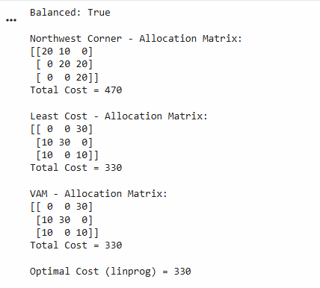

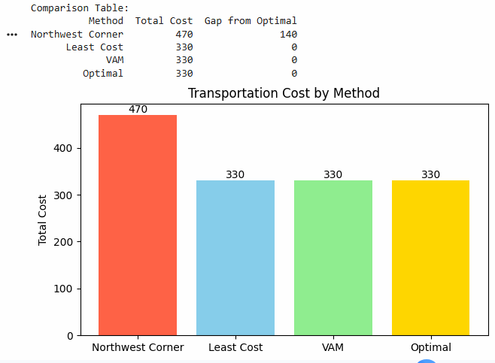
Output Analysis | - The Northwest Corner Method gave the highest cost (470) because it allocates by position and ignores unit costs. It is 140 above the optimal cost.  - The Least Cost Method gave 330 by allocating first to the cheapest cells, such as S1→D3 (cost 1).  - VAM also gave 330, since its highest penalty (D3) locked in the cheap S1→D3 route first.  - The optimal cost from linprog is 330, so LCM and VAM already

reached the optimal solution and no Stepping Stone improvement is

needed.
- All three solutions are feasible, with total shipped = 90.
Link of student Github profile where lab assignment has | https://github.com/HrutikGujarkar/Optimizaton-techniques-Practicals

Department of Computer Technology

Vision of the Department
To be a well-known centre for pursuing computer education through innovative pedagogy, value-based education and industry collaboration.

Mission of the Department
To establish learning ambience for ushering in computer engineering professionals in core and multidisciplinary area by developing Problem-solving skills through emerging technologies.

been uploaded
Conclusion | The Transportation Problem was solved using the Northwest Corner Method, Least Cost Method and Vogel’s Approximation Method. The Northwest Corner Method gave a total cost of 470, while both the Least Cost Method and VAM gave 330, which matches the optimal cost verified using linprog. Hence, methods that use cost information give better initial feasible solutions than the Northwest Corner Method, and in this problem LCM and VAM reached the optimal solution directly, so no further improvement was needed.
Plag Report (Similarity index < 12%) | <= 9 %

